**LAB 01**

**CSC-340L**

*ISE Installation and Setup Guides (Ubuntu 19.04 and Windows 10)*

Christopher Apodaca, Teerathpreet Sekhon

Feb. 7, 2020

**UBUNTU 19.04 SETUP GUIDE**

**Step 01**

Navigate to the XILINX download page: https://www.xilinx.com/support/download.html

Select the appropriate Linux installation from the list of available downloads,” XILINX Installer 2019.2: Linux Self Extracting Web Installer

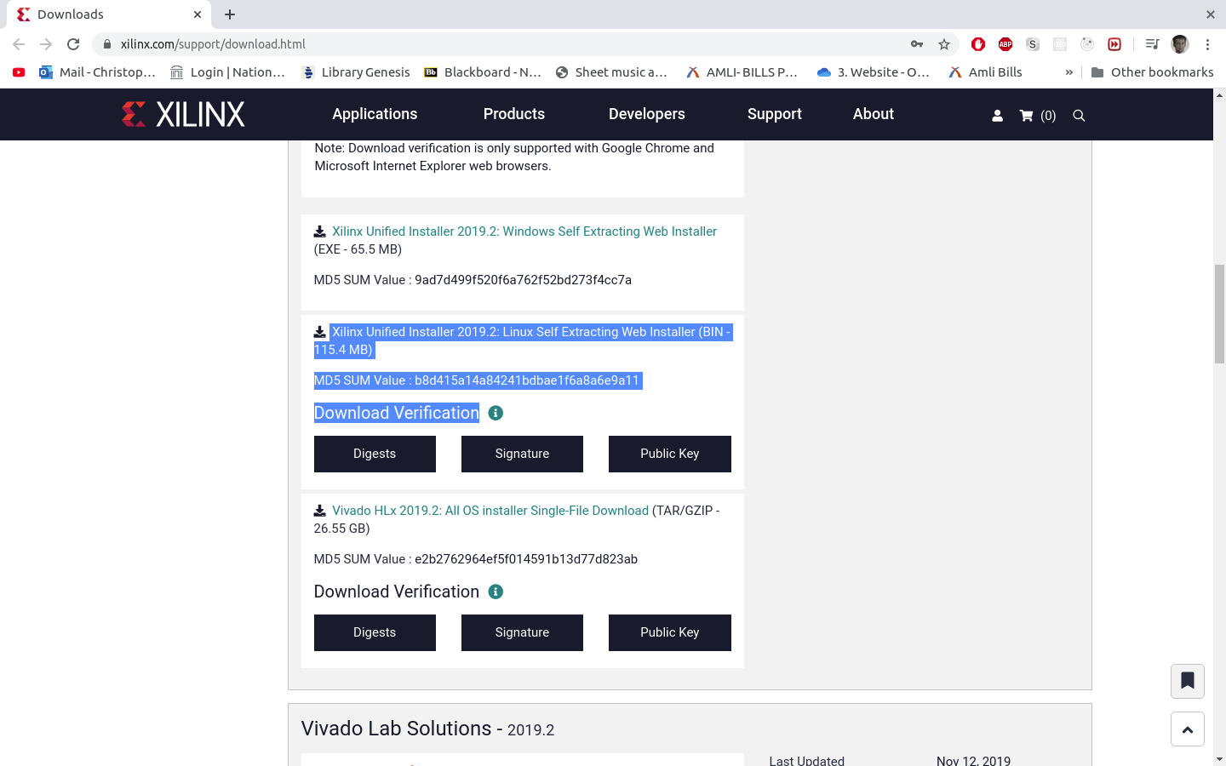

**Step 02**

Open the linux terminal/shell and create a new directory in your home directory called xilinx:

*$ mkdir ~/xilinx/*

**Step 03**

Move the binary file into the newly created directory ( if it’s in downloads folder ):

*$ mv ~/Downloads/Xilinx_Unified_2019.2_1106_2127_Lin64.bin ~/xilinx/*

**Step 04**

Navigate to the xilinx directory:

*$ cd ~/xilinx/*

**Step 05**

Change file permissions to allow execution:

*$ chmod 777 Xilinx_Unified_2019.2_1106_2127_Lin64.bin*

**Step 06**

Run the binary file as super user:

*$ sudo ./*Xilinx_Unified_2019.2_1106_2127_Lin64.bin

**Step 07**

**Agree to license terms and let the extraction/installation process take place. This can take up to 45 minutes:**

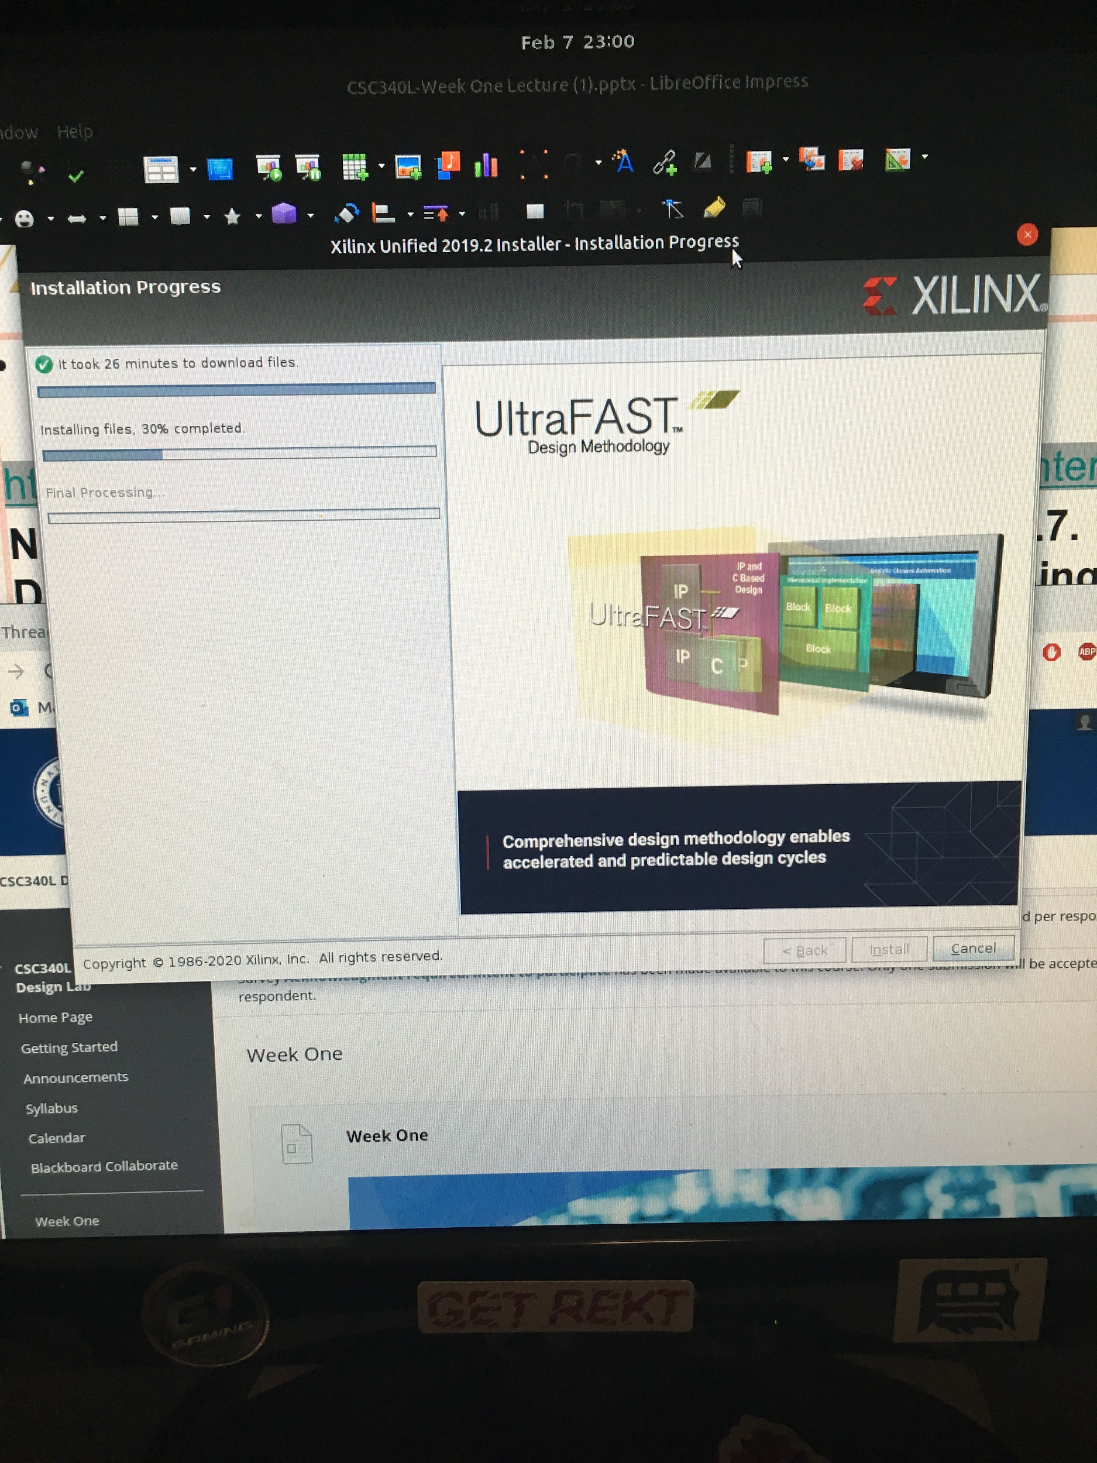

**Step 08:**

Source the application by navigating inside the installation directory, the bin directory, and the 2019.2 directory ( add to .bash_profile or .bashrc if you want on boot):

*$ source xilinx/install/Vivado/2019.2/settings64.sh*

**STEP 09:**

Now run the application as a service:

*$ vivado &*

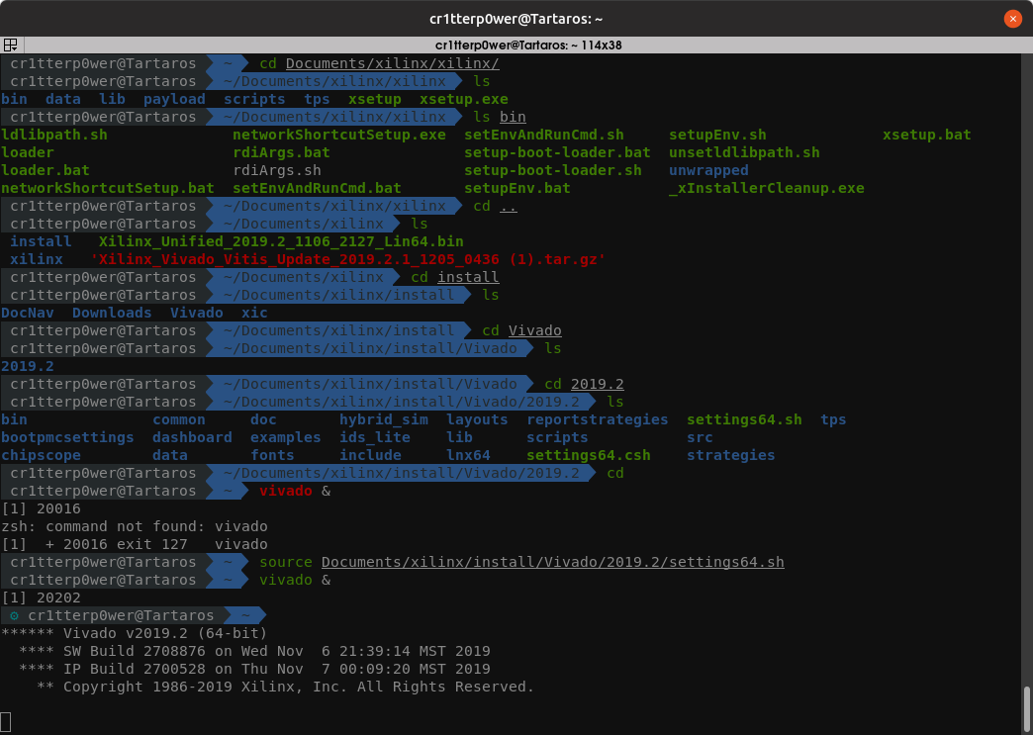

**Step 10:**

**Select New Project**

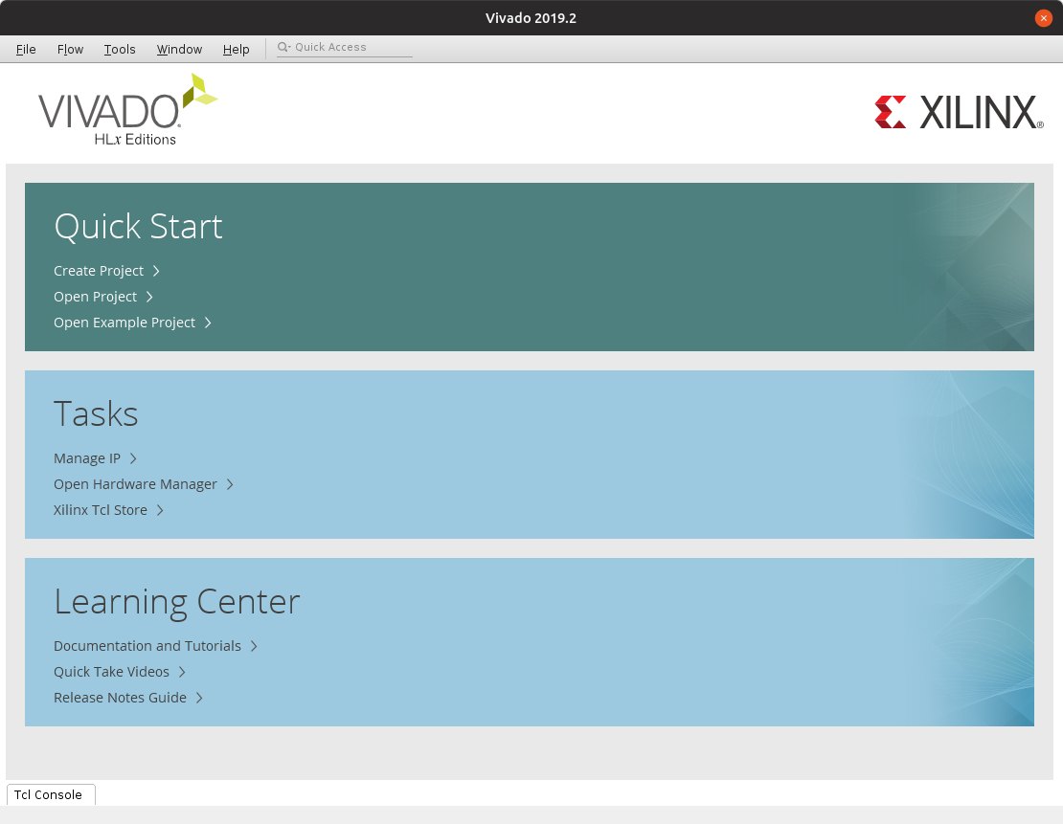

**Step 11:**

**C all project Lab1**

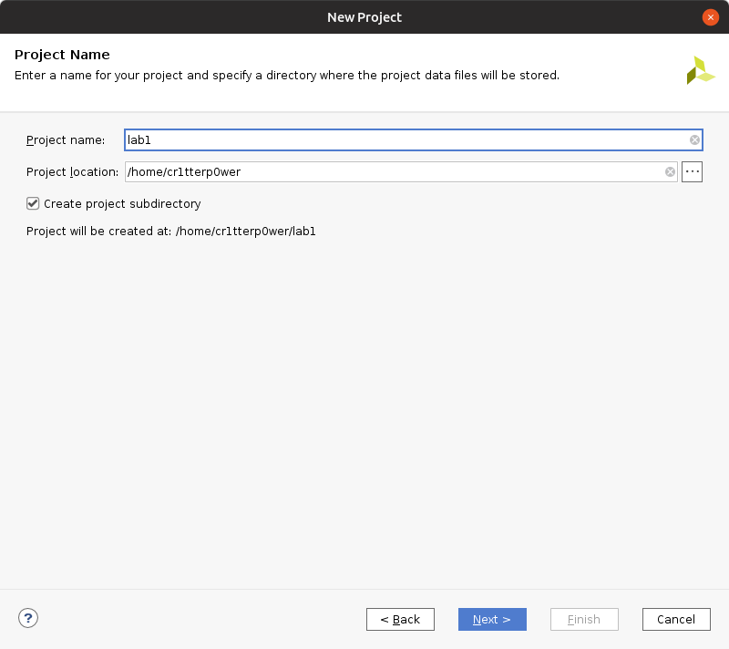

**Step 12:**

**Select Project type**

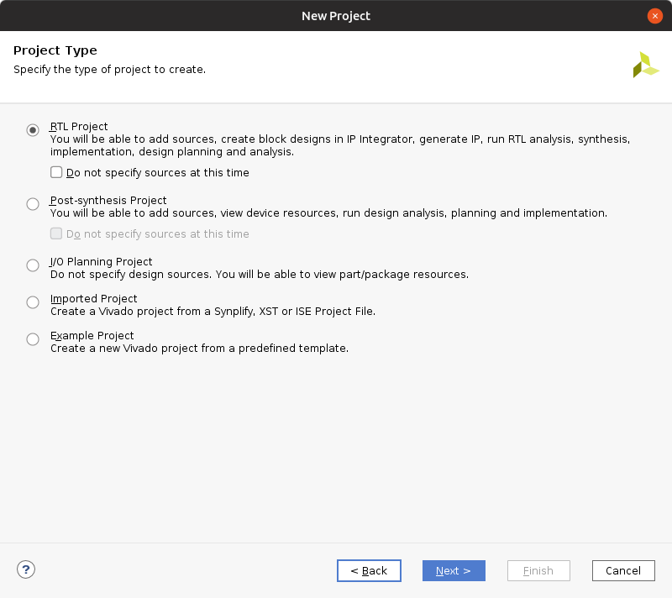

**Step 13:**

**Finalize setup and begin**

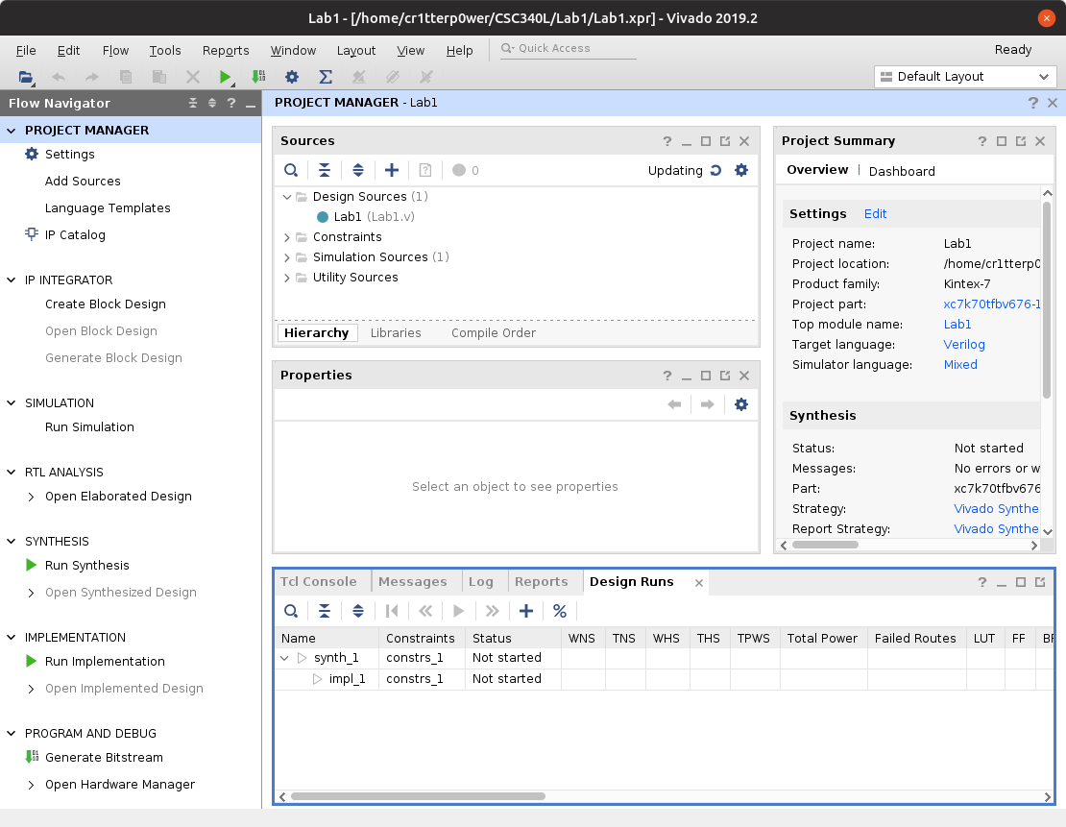

**WINDOWS 10 SETUP GUIDE**

How to download and install Xilinx 14.7ISE Windows 10

1. The first thing that you need to do is go to <https://www.xilinx.com/> and create an account. There will be a create account option in the upper right corner of the page.
2. Next, follow the provided link. <https://www.xilinx.com/support/download/index.html/content/xilinx/en/downloadNav/vivado-design-tools/archive-ise.html>
3. Click on **ISE Archive** under the tab on the left and then under **14x** select **14.7** and not 14.7 windows 10.
4. Under **ISE Design Suite** download the **Full Installer for Windows 7/server/xp**



1. Next you will be led to a US customs export form where you will need to fill out your personal information.
2. After the download has started, head to <https://www.7-zip.org/> and download **7-zip** for windows 10 and choose the **64 bit** version

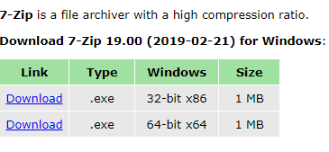

1. Click on the downloaded file and run the 7-zip installer.
2. Once the Xilinx file has downloaded it, locate it in your downloads and then right click and choose **7-zip -> Extract files**

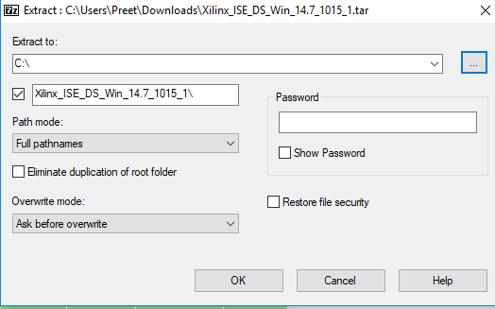

1. A window like shown above should appear if you have chosen the correct option where you can choose to extract the files to a location of your choosing. After choosing a location, click ok and let the files extract.
2. Next there should be a file called **Xilinx_ISE_DS_14.7_1015_1** where you chose to extract the files in the previous step. Open the file and locate the application called **xsetup**. The 14.7 installer should be running now.
3. Click next and agree to the 2 license agreements and then the 3rd one on the next page. Under **Edition List** select **ISE WebPACK.** After this step, do not change any other options and click next through until the installation has begun.

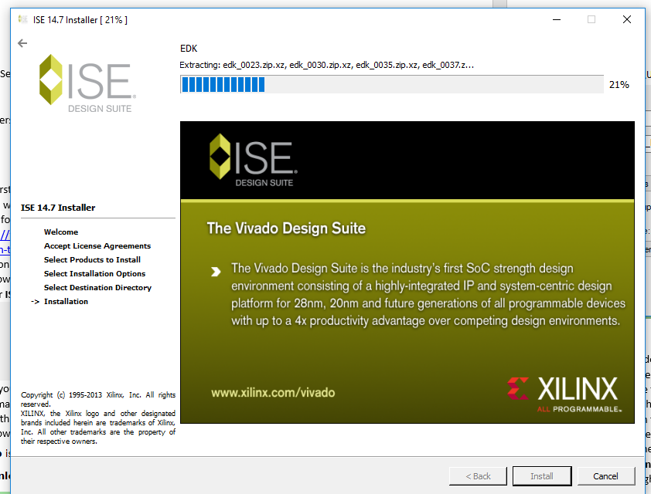

*This is how the installation window will look.*

1. Once the installation is complete, head to where the program was installed in the C drive. There will be a file called **Xilinx. Open Xilinx -> 14.7 -> ISE_DS -> ISE -> lib -> nt64**
2. Here, find the file called **libPortability.dll** and rename it to **libPortability.dll.orig**
3. Next, copy the file **libPortabilityNOSH.dll**. Then paste the selected file, it should be called **libPortabilityNOSH – Copy.dll.** Rename this file to **lidPortability.dll**
4. Next, go back to the **ISE_DS folder** and then open **common->lib->nt64** and then past the **libPortabilityNOSH.dll** file from the other **lib** folder form the previous step into this one.
5. Rename the file **libPortability.dll** to **libPortability.dll.orig**
6. Rename the file **libPortabilityNOSH.dll** to **lidPortability.dll**



* The files should be named as above.

1. Next, launch the **Ise Design suite 14.7**. You will be greeted by a message that says you need a license. Select ok and then a window will appear where you can choose **Get My Purchased License(s)** and then click next.
2. Next a window will appear that will connect you default browser to a licensing page. Click next and then you will be prompted to sign into **Xilinx.com**
3. You will be redirected to your personal information page where you can confirm that the information you have submitted is correct.
4. After verifying that your information is correct, you will be led to a page to select the proper license needed.



* This is the license that you need to acquire. Click on it and then agree to the terms and conditions.

1. The license will then be emailed to you as an attachment file. Download the file.
2. Then in the **Xilinx License Configuration manager** window, select **Load License.** Find you .lic file and select it.
3. Next you will get a message stating that your license has been accepted and you are now free to create projects using the software and the instillation and set up is complete.

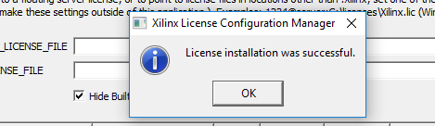

**Create a New Project**

1. In **ISE Design Suite** select **New Project** from the upper right corner.
2. Change the location that you would like to store your project by changing the location and give your project a name.

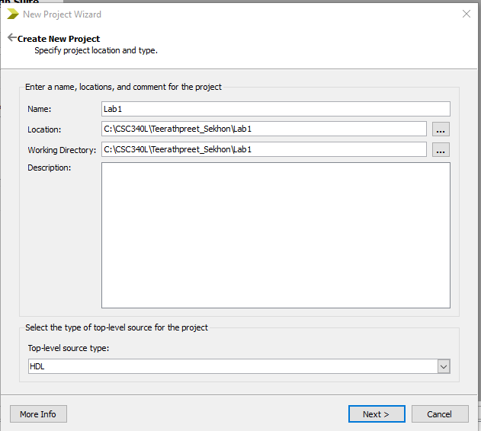

1. Configure the set-up options to your preference and then finalize them.
2. Next, right click your project name under the **Hierarchy** tab and select **New Source, Verilog Module** and then name it.

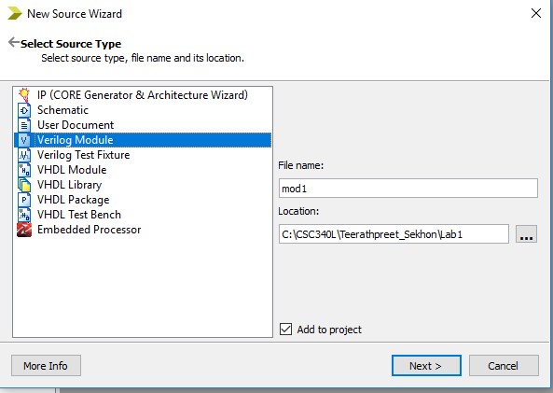

1. Choose the number of inputs, click next and then click finish. The module should now show up under your project.

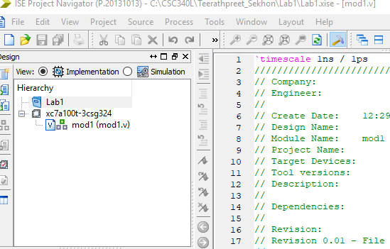

Proof

